Chapter 5, Problem 91

A noninverting current amplifier is portrayed in Fig. 5.108. Calculate the gain i_{o}/i_{s}. Take R₁ = 8 kΩ and R₂ = 1 kΩ.

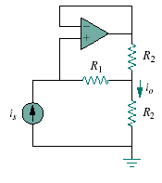
Figure 5.108
For Prob. 5.91.

